Walmart Project
Hai Phan

Research Question
Average temperatures have been rising over time. In the short term, Wal-Mart is curious whether this might hurt its sales. In these stores, do higher temperatures causally affect sales?

Data
The CSV file Walmart_Sales.csv contains sales data for 45 Walmart stores from February 2010 through October 2012. This data contains the columns:
Store: the store number
Date: the week of the sale in day-month-year format
Weekly_Sales: the sales for the given store in the given week
Holiday_Flag: whether the week is a special holiday week (1) or not
Temperature: the average temperature in the region (in Fahrenheit)
Fuel_Price: the cost of fuel in the region (in dollars per gallon)
CPI: the consumer price index
Unemployment: the unemployment rate in the region

Causal Diagram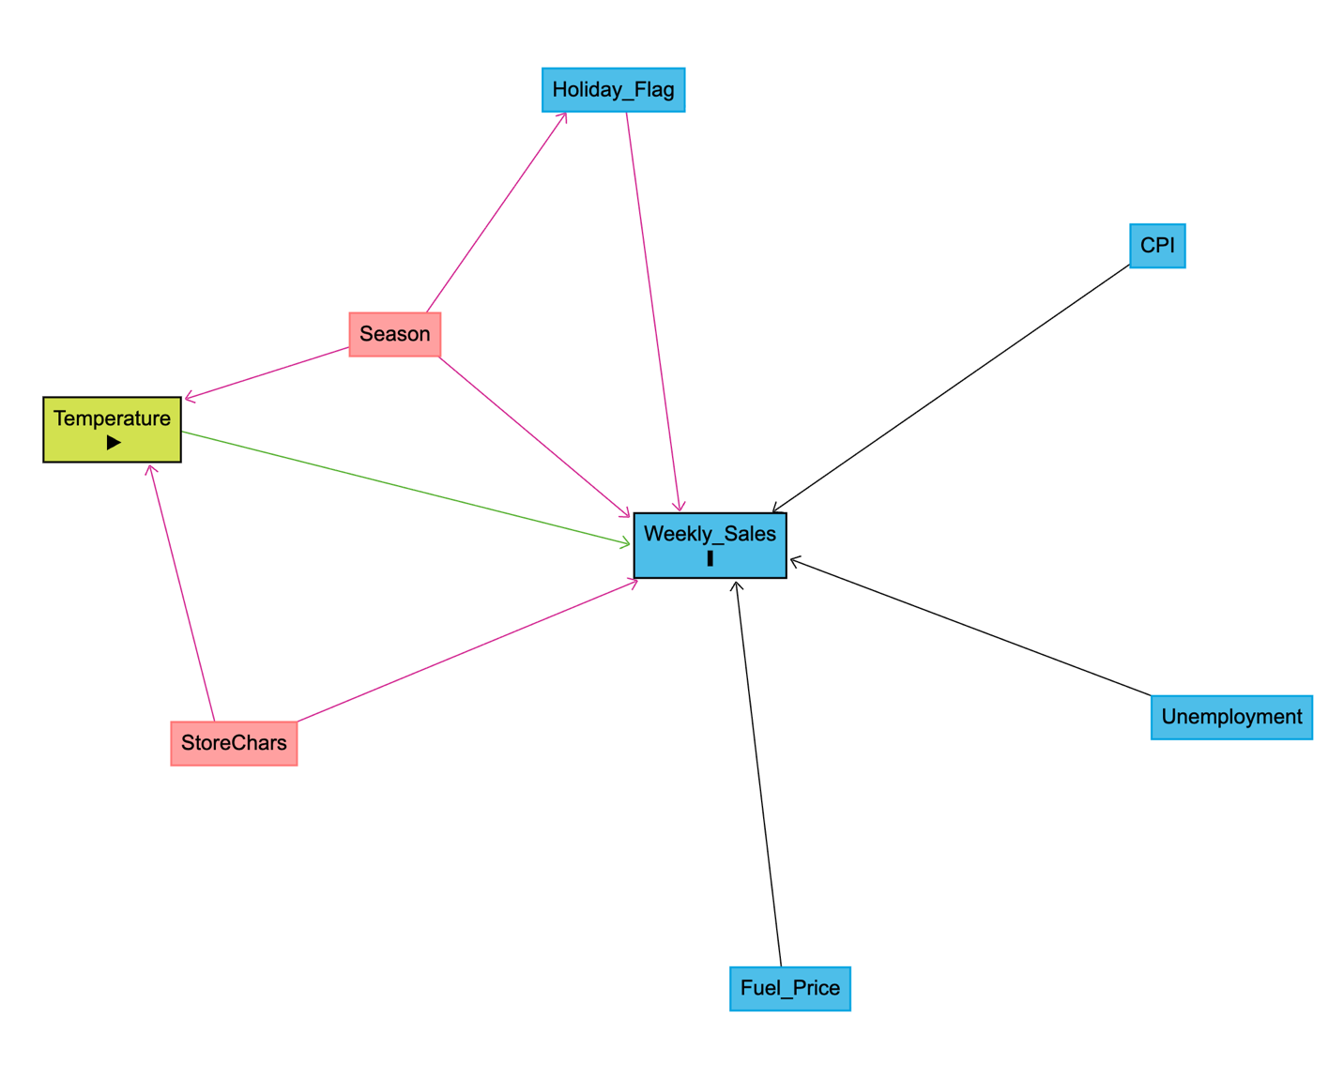

A causal diagram helps show what the analysis is trying to learn, which is whether temperature affects weekly sales. It also shows other factors that could make temperature and sales look related, even if temperature is not the real reason. In this dataset, season is important because temperature changes across the year, and shopping behavior can also change by season and around holidays. Store characteristics also matter because stores in different places can have different typical temperatures and different normal sales levels. Drawing the diagram helps identify these possible sources of confusion and guides which variables should be controlled for.

Based on the diagram, the two biggest sources of confounding are seasonality and stable differences across stores. “StoreChars” represents store characteristics such as store size, location, and the usual customer base. These do not change much over time, so they are handled using store fixed effects. This makes the model compare each store to itself over time instead of comparing different stores to each other.

Seasonality can also matter because temperature moves with the time of year, and shopping patterns can change by season and around holidays. A “Season” variable is not in the dataset, but it could be created from the Date variable (for example, month or week-of-year) as an extra robustness check if needed. In the main analysis, the model uses store fixed effects and several controls (Holiday_Flag, Fuel_Price, CPI, and Unemployment) to reduce the chance that the temperature effect is driven by holiday timing or broader economic conditions.

Running Code
library(lubridate)
library(ggplot2)
library(lmtest)
library(sandwich)
Walmart_Sales <- read.csv("Walmart_Sales.csv")
- Step 1: Load the data

First, the required R packages were loaded for dates, plotting, and standard errors. Then the dataset was imported from Walmart_Sales.csv.

- Step 2: Quick check
I checked the dataset to make sure the variables loaded correctly.
Next, I cleaned a few variables, so they work well in the analysis. Date was converted from text to a real date format. Store was converted to a factor, so store fixed effects can be used, which means the model compares the same store over time instead of comparing different stores. Holiday_Flag was also converted to a factor because it is a 0/1 indicator.
In this project, no new variables were required for the main regressions because the dataset already includes the key variables used in the models. However, a simple season variable can still be created from Date (such as month or week-of-year) as an optional robustness check to separate a temperature effect from general seasonal shopping patterns.
Walmart_Sales$Date <- dmy(Walmart_Sales$Date)
Walmart_Sales$Store <- factor(Walmart_Sales$Store)
Walmart_Sales$Holiday_Flag <- factor(Walmart_Sales$Holiday_Flag)
- Step 3: Exploratory plot (visual check)
ggplot(Walmart_Sales, aes(x = Temperature, y = Weekly_Sales)) +
geom_point(alpha = 0.25) +
geom_smooth(method = "lm", se = TRUE) +
labs(title = "Weekly Sales vs Temperature", x = "Temperature", y = "Weekly Sales")
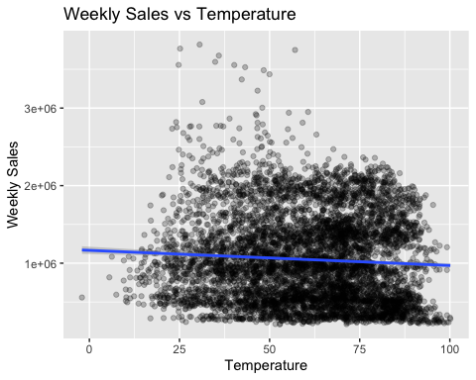
The scatter plot with a fitted line shows a small downward trend between Temperature and Weekly_Sales. In other words, when the temperature is higher, weekly sales tend to be slightly lower. However, the points are very spread out, which means sales vary a lot even at the same temperature. This suggests that many other factors besides temperature affect sales. Because of that, this plot is only a visual check, and it supports the need for regression models with controls and store fixed effects.

Temperature might affect sales in the same week because people can change shopping plans quickly when the weather changes. It might also affect sales with a delay if customers postpone shopping to next week. In this project, temperature is matched with sales in the same week because the data are weekly, and this is the most direct way to line up the variables. A lagged temperature variable could be added as an extra check to see whether the effect shows up one week later.

- Step 4: Regression Models
I estimated three regressions to see how the temperature effect changes as I control for more confounding factors:
Model 1 (baseline): Weekly Sales ~ Temperature
m1 <- lm(Weekly_Sales ~ Temperature, data = Walmart_Sales)
Model 2 (with controls): Weekly_Sales ~ Temperature + Holiday_Flag + Fuel_Price + CPI + Unemployment
m2 <- lm(Weekly_Sales ~ Temperature + Holiday_Flag + Fuel_Price + CPI + Unemployment, data = Walmart_Sales)
Model 3 (store fixed effects): Weekly_Sales ~ Temperature + Holiday_Flag + Fuel_Price + CPI + Unemployment + Store
m3 <- lm(Weekly_Sales ~ Temperature + Holiday_Flag + Fuel_Price + CPI + Unemployment + Store, data = Walmart_Sales)
coef(m1)["Temperature"]
Temperature
-1952.419
coef(m2)["Temperature"]
Temperature
-724.1715
summary(m3)$coefficients["Temperature", ]
Estimate Std. Error t value Pr(>|t|)
-8.337115e+02 1.317498e+02 -6.327990e+00 2.652190e-10
Interpret:
The Temperature coefficient means that a one-degree increase in temperature, holding the other variables constant, is associated with a decrease in weekly sales. In the preferred model with store fixed effects, a one-degree increase in temperature is associated with about 834 dollars lower weekly sales on average.
Result: Model 3 is the preferred model because adding store fixed effects removes stable differences across stores, such as store size, location, or typical customer base. This means the temperature effect is identified from changes within the same store over time rather than differences between stores. Even with fixed effects, the estimate could still be influenced by other factors that change over time and are related to both temperature and sales, so controls are still useful. One remaining concern is that sales may follow seasonal patterns that move with temperature, so adding month or week fixed effects from Date would be a useful robustness check.
After estimating Model 3, the temperature coefficient is negative and statistically significant, which means higher temperature is associated with lower weekly sales in the data. Because the same store appears many times across weeks, errors may be correlated within a store over time. To avoid overstating significance, standard errors are clustered by store. After clustering, the temperature result remains significant with a p-value of 0.005, so the conclusion does not depend on unadjusted standard errors.
- Step 5: Conclusion
Overall, the results suggest that higher temperatures are linked to lower weekly sales in this Walmart dataset. In the preferred model with controls and store fixed effects, the temperature coefficient is about -834. This means that when the temperature increases by one degree Fahrenheit, weekly sales in the same store are associated with about 834 dollars lower sales on average, after accounting for the other variables in the model. This estimate comes from comparing each store to itself over time after accounting for holidays and local economic conditions. This result stays statistically significant when using standard errors clustered by store, which is more appropriate because the data contain repeated weekly observations for the same stores.
At the same time, a causal claim still depends on an important assumption. Even with store fixed effects and the included controls, other factors could change over time within a store and move with temperature while also affecting sales. For example, local events, seasonal shopping habits, or store promotions might change at the same time as the weather. Because of these possible time-varying factors, the findings provide clear evidence of a negative relationship and are consistent with a causal effect, but they should still be interpreted with caution.
No log transformation was used because weekly sales are already measured in dollars, so the results are easy to read as dollar changes. A log model is usually more helpful when sales have extreme outliers or when the goal is to describe percent changes. In this project, the linear model provides a clear baseline, and a log version would only be added if the sales distribution looks highly skewed.

